LAB PROGRAM 1
Method Overriding in Java
Method overriding means changing the behavior of a parent class method in the child class using the same method name and parameters.
Example 1
// Parent class
class Animal {
void sound() {
System.out.println("Animal makes a sound");
}
}

// Child class
class Dog extends Animal {
// Overriding the sound() method
void sound() {
System.out.println("Dog barks");
}
}

// Main class
public class Main {
public static void main(String[] args) {
Animal a = new Dog(); // Parent reference, child object
a.sound(); // Calls Dog's method
}
}

Output
Dog barks

Example 2
Method Overriding with Parameters
// Parent class
class Bank {
double getInterestRate(double amount) {
return amount * 0.05; // 5% interest
}
}

// Child class
class SBI extends Bank {
// Overriding method with same parameter
double getInterestRate(double amount) {
return amount * 0.06; // 6% interest
}
}

// Main class
public class Main {
public static void main(String[] args) {
Bank b = new SBI(); // Parent reference, child object
System.out.println(b.getInterestRate(10000));
}
}

Output
600.0

Interface in Java

Example 1
Java Program Using Interface (Area Calculation)
// Interface
interface Shape {
double calculateArea();
}

// Rectangle class
class Rectangle implements Shape {
double length, width;

Rectangle(double length, double width) {
this.length = length;
this.width = width;
}

public double calculateArea() {
return length * width;
}
}

// Square class
class Square implements Shape {
double side;

Square(double side) {
this.side = side;
}

public double calculateArea() {
return side * side;
}
}

// Triangle class
class Triangle implements Shape {
double base, height;

Triangle(double base, double height) {
this.base = base;
this.height = height;
}

public double calculateArea() {
return 0.5 * base * height;
}
}

// Main class
public class Main {
public static void main(String[] args) {
Shape r = new Rectangle(10, 5);
Shape s = new Square(4);
Shape t = new Triangle(6, 3);

System.out.println("Area of Rectangle: " + r.calculateArea());
System.out.println("Area of Square: " + s.calculateArea());
System.out.println("Area of Triangle: " + t.calculateArea());
}
}
Output
Area of Rectangle: 50.0
Area of Square: 16.0
Area of Triangle: 9.0

Abstract Class in Java
Example 1
abstract class Animal {
// Abstract method
abstract void sound();

// Method with implementation
void sleep() {
System.out.println("Animal is sleeping");
}
}

class Dog extends Animal {
// Implementing abstract method
void sound() {
System.out.println("Dog barks");
}
}

public class Main {
public static void main(String[] args) {
Dog d = new Dog();
d.sound(); // Calls overridden method
d.sleep(); // Calls implemented method in abstract class
}
}
Output
Dog barks
Animal is sleeping

Example 2

Abstract Class Example (Area Calculation)
abstract class Shape {
// Abstract method
abstract double calculateArea();

// Concrete method (method implementation)
void display() {
System.out.println("Area Calculation using Abstract Class");
}
}

class Rectangle extends Shape {
double length, width;

Rectangle(double length, double width) {
this.length = length;
this.width = width;
}

double calculateArea() {
return length * width;
}
}

class Square extends Shape {
double side;

Square(double side) {
this.side = side;
}

double calculateArea() {
return side * side;
}
}

class Triangle extends Shape {
double base, height;

Triangle(double base, double height) {
this.base = base;
this.height = height;
}

double calculateArea() {
return 0.5 * base * height;
}
}

public class Main {
public static void main(String[] args) {
Shape rectangle = new Rectangle(10, 5);
Shape square = new Square(4);
Shape triangle = new Triangle(6, 3);

rectangle.display();
System.out.println("Area of Rectangle: " + arectangle.calculateArea());

square.display();
System.out.println("Area of Square: " + square.calculateArea());

triangle.display();
System.out.println("Area of Triangle: " + triangle.calculateArea());
}
}

Output
Area Calculation using Abstract Class
Area of Rectangle: 50.0
Area Calculation using Abstract Class
Area of Square: 16.0
Area Calculation using Abstract Class
Area of Triangle: 9.0

Example 3
// Interface for Term 1
interface Term1 {
int term1Total();
}

// Interface for Term 1 and Term 2
interface Term2 extends Term1 {
int term2Total();
}

// Interface for Term 1, Term 2 and Term 3
interface Term3 extends Term2 {
int term3Total();
}

// Class implementing all interfaces
class Student implements Term3 {
int t1, t2, t3;

Student(int t1, int t2, int t3) {
this.t1 = t1;
this.t2 = t2;
this.t3 = t3;
}

public int term1Total() {
return t1;
}

public int term2Total() {
return t1 + t2;
}

public int term3Total() {
return t1 + t2 + t3;
}
}

// Main class
public class Main {
public static void main(String[] args) {
Student s = new Student(25, 30, 28);

System.out.println("Term 1 Total Marks: " + s.term1Total());
System.out.println("Term 1 + Term 2 Total Marks: " + s.term2Total());
System.out.println("Term 1 + Term 2 + Term 3 Total Marks: " + s.term3Total());
}
}
Output
Term 1 Total Marks: 25
Term 1 + Term 2 Total Marks: 55
Term 1 + Term 2 + Term 3 Total Marks: 83

LAB PROGRAM 2
Title : Implement a Singleton Pattern in Java
Problem Description: students must implement the class called database connection that act as a
singleton class to provide connection to the clients to access the data from database.
Method: Create a class call DatabaseConnect with following
1. Add a private static field to the class for storing the singleton instance.
2. Declare a public static creation method for getting the singleton instance.
3. Implement “lazy initialization” inside the static method. It should create a new object on its first
call and put it into the static field. The method should always return that instance on all
subsequent calls.
4. Make the constructor of the class private. The static method of the class will still be able to call
the constructor, but not the other objects.
5. Write the client code and replace all direct calls to the singleton’s constructor with calls to its
static creation method.

Components of Singleton Pattern (GoF)

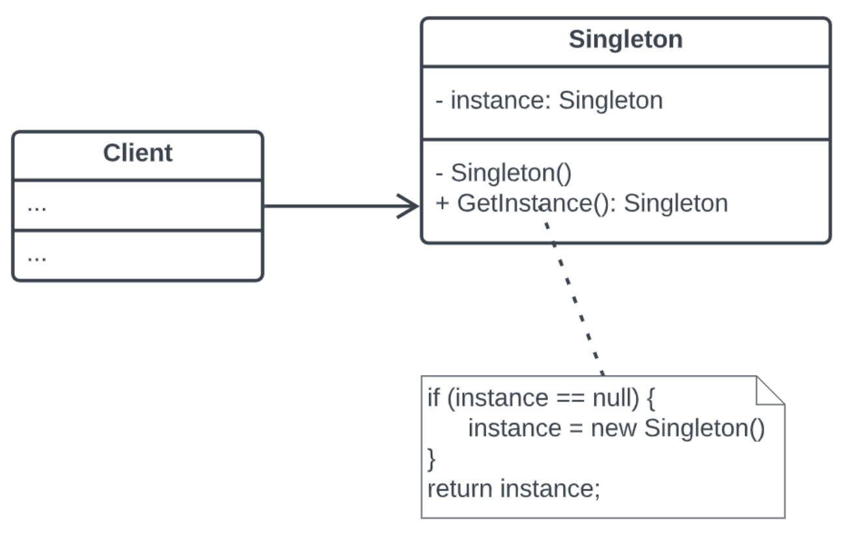
- Singleton Class
  - The class that is designed to have only one instance.
- Private Static Instance
  - A static member of the class that holds the single instance.
  - Ensures only one object per JVM.
- Private Constructor
  - Prevents other classes from creating new instances using new.
  - Ensures controlled instantiation.
- Public Static Accessor Method (getInstance())
  - Provides a global point of access to the single instance.
  - Can perform lazy initialization (creates instance on first call).
- Business Methods / Functionality
  - Methods that allow the singleton to perform actions.
  - Example: showMessage(), doSomething().
- Client
  - Code that uses the singleton via the accessor method.
  - Cannot create new instances directly.
Program
class Singleton {

// single instance
private static Singleton instance;

// private constructor
private Singleton() {
System.out.println("Singleton instance created!");
}

// global access point
public static Singleton getInstance() {
if (instance == null) {
instance = new Singleton();
}
return instance;
}
}

public class Main {
public static void main(String[] args) {

// Trying to get two objects
Singleton obj1 = Singleton.getInstance();
Singleton obj2 = Singleton.getInstance();

// This prints "true" because both references point to the same object
System.out.println(obj1 == obj2);

// Output shows the constructor message only once
}
}

Program Explanation

1. Singleton Class → defines the pattern
class Singleton {
...
}
- The class Singleton itself implements the singleton design pattern.
- All components of the pattern are inside this class.

2. Private Constructor → prevents external instantiation
private Singleton() {
System.out.println("Singleton instance created!");
}
- private ensures no other class can create a new instance using new Singleton().
- Here, it also prints a message to show when the singleton is created.

3. Private Static Instance → stores the single object
private static Singleton instance;
- A static field that will hold the only instance of the class.
- Ensures there’s only one object in the JVM.
- Static variables belong to the class, not to any object.
- So instance is shared by all objects (or even when no object exists).

4. Public Static Accessor (getInstance()) → global access point
public static Singleton getInstance() {
if (instance == null) {
instance = new Singleton();
}
return instance;
}

- Provides a global point of access for clients.
- Implements lazy initialization: the instance is created only when first requested.

5. Business Methods → functionality of the singleton
- In your example, you don’t have extra methods, but the constructor prints a message, which is your “functionality” for demo purposes:
System.out.println("Singleton instance created!");

- You could also add a method like:
public void showMessage() {
System.out.println("Hello from Singleton!");
}

6. Client Code → consumes the singleton instance
public class Main {
public static void main(String[] args) {
Singleton obj1 = Singleton.getInstance();
Singleton obj2 = Singleton.getInstance();

System.out.println(obj1 == obj2); // true
}
}

- The Main class is the client.
- It accesses the singleton via getInstance() instead of using new.
- The obj1 == obj2 check confirms that both references point to the same object.
PRACTICE PROGRAM
Practice Program
Title: Implement FACTORY pattern in java.

Components of FACTORY Pattern (GoF)
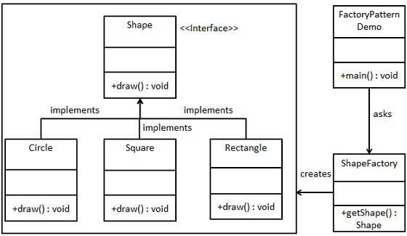

Step 1
//Create an interface.

//Shape.java
public interface Shape {
void draw();
}

Step 2
//Create concrete classes implementing the same interface.

//Rectangle.java
public class Rectangle implements Shape {
@Override
public void draw() {
System.out.println("Inside Rectangle::draw() method.");
}
}

//Square.java
public class Square implements Shape {
@Override
public void draw() {
System.out.println("Inside Square::draw() method.");
}
}

//Circle.java
public class Circle implements Shape {
@Override
public void draw() {
System.out.println("Inside Circle::draw() method.");
}
}

Step 3
Create a Factory to generate object of concrete class based on given information.

//ShapeFactory.java
public class ShapeFactory {
//use getShape method to get object of type shape
public Shape getShape(String shapeType){
if(shapeType == null){
return null;
}
if(shapeType.equalsIgnoreCase("CIRCLE")){
return new Circle();

} else if(shapeType.equalsIgnoreCase("RECTANGLE")){
return new Rectangle();

} else if(shapeType.equalsIgnoreCase("SQUARE")){
return new Square();
}
return null;
}
}

//Example - Usage of Factory Design Pattern
//Use the Factory to get object of concrete class by passing an information such as type.

//FactoryPatternDemo.java
public class FactoryPatternDemo {
public static void main(String[] args) {
ShapeFactory shapeFactory = new ShapeFactory();
//get an object of Circle and call its draw method.
Shape shape1 = shapeFactory.getShape("CIRCLE");
//call draw method of Circle
shape1.draw();
//get an object of Rectangle and call its draw method.
Shape shape2 = shapeFactory.getShape("RECTANGLE");
//call draw method of Rectangle
shape2.draw();
//get an object of Square and call its draw method.
Shape shape3 = shapeFactory.getShape("SQUARE");
//call draw method of square
shape3.draw();
}
}

Output
Verify the output.
Inside Circle::draw() method.
Inside Rectangle::draw() method.
Inside Square::draw() method.

PRACTICE PROGRAM
Abstract Factory
Abstract Factory patterns work around a super-factory which creates other factories.
This factory is also called as factory of factories.
This type of design pattern comes under creational pattern as this pattern provides one of the best ways to create an object.
In Abstract Factory pattern an interface is responsible for creating a factory of related objects without explicitly specifying their classes.
Each generated factory can give the objects as per the Factory pattern.

AbstractFactoryPatternDemo, our demo class uses FactoryProducer to get a AbstractFactory object. It will pass information (CIRCLE / RECTANGLE / SQUARE for Shape) to AbstractFactory to get the type of object it needs. It also passes information (RED / GREEN / BLUE for Color) to AbstractFactory to get the type of object it needs.
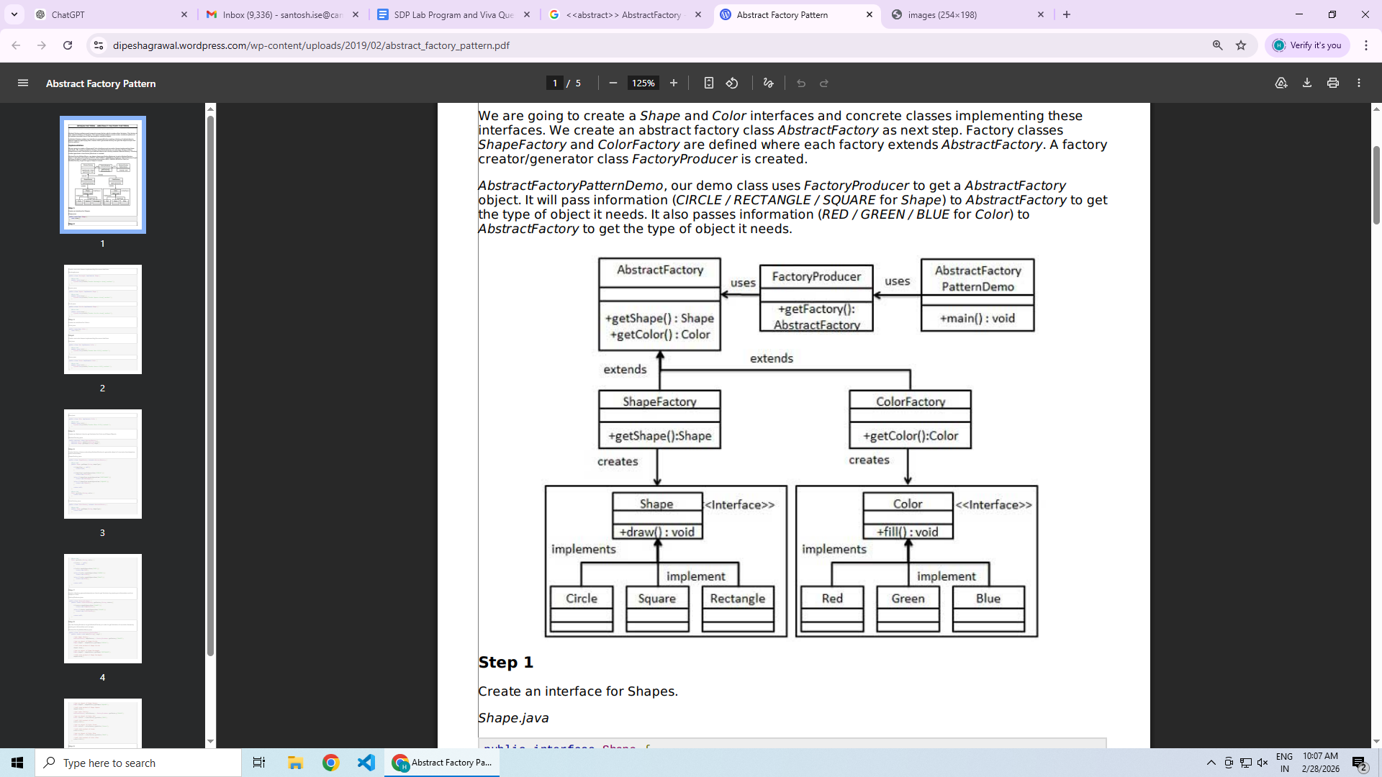

Component | In Your Program
Abstract Factory | AbstractFactory.java
Concrete Factories | ShapeFactory.java, ColorFactory.java
Abstract Products | Shape.java, Color.java
Concrete Products | Circle, Rectangle, Square, Red, Green, Blue
Client | AbstractFactoryPatternDemo.java

Program
// Abstract Factory Design Pattern - Single File Program

// ===== Abstract Product - Shape =====
interface Shape {
void draw();
}

// ===== Concrete Shape Classes =====
class Rectangle implements Shape {
@Override
public void draw() {
System.out.println("Inside Rectangle::draw() method.");
}
}

class Square implements Shape {
@Override
public void draw() {
System.out.println("Inside Square::draw() method.");
}
}

class Circle implements Shape {
@Override
public void draw() {
System.out.println("Inside Circle::draw() method.");
}
}

// ===== Abstract Product - Color =====
interface Color {
void fill();
}

// ===== Concrete Color Classes =====
class Red implements Color {
@Override
public void fill() {
System.out.println("Inside Red::fill() method.");
}
}

class Green implements Color {
@Override
public void fill() {
System.out.println("Inside Green::fill() method.");
}
}

class Blue implements Color {
@Override
public void fill() {
System.out.println("Inside Blue::fill() method.");
}
}

// ===== Abstract Factory =====
abstract class AbstractFactory {
abstract Shape getShape(String shape);
abstract Color getColor(String color);
}

// ===== Shape Factory =====
class ShapeFactory extends AbstractFactory {

@Override
public Shape getShape(String shapeType) {
if (shapeType == null) {
return null;
}
if (shapeType.equalsIgnoreCase("CIRCLE")) {
return new Circle();
} else if (shapeType.equalsIgnoreCase("RECTANGLE")) {
return new Rectangle();
} else if (shapeType.equalsIgnoreCase("SQUARE")) {
return new Square();
}
return null;
}

@Override
Color getColor(String color) {
return null;
}
}

// ===== Color Factory =====
class ColorFactory extends AbstractFactory {

@Override
public Shape getShape(String shapeType) {
return null;
}

@Override
Color getColor(String color) {
if (color == null) {
return null;
}
if (color.equalsIgnoreCase("RED")) {
return new Red();
} else if (color.equalsIgnoreCase("GREEN")) {
return new Green();
} else if (color.equalsIgnoreCase("BLUE")) {
return new Blue();
}
return null;
}
}

// ===== Factory Producer =====
class FactoryProducer {
public static AbstractFactory getFactory(String choice) {
if (choice.equalsIgnoreCase("SHAPE")) {
return new ShapeFactory();
} else if (choice.equalsIgnoreCase("COLOR")) {
return new ColorFactory();
}
return null;
}
}

// ===== Client / Main Class =====
public class AbstractFactoryPatternDemo {
public static void main(String[] args) {

// Get Shape Factory
AbstractFactory shapeFactory =
FactoryProducer.getFactory("SHAPE");

Shape shape1 = shapeFactory.getShape("CIRCLE");
shape1.draw();

Shape shape2 = shapeFactory.getShape("RECTANGLE");
shape2.draw();

// Get Color Factory
AbstractFactory colorFactory =
FactoryProducer.getFactory("COLOR");

Color color1 = colorFactory.getColor("RED");
color1.fill();

Color color2 = colorFactory.getColor("GREEN");
color2.fill();
}
}

Step-by-Step Explanation of the Program

1.Abstract Products
These are the interfaces that define common behavior.

➤ Shape Interface
interface Shape {
void draw();
}
- Declares draw() method.
- All shape classes must implement this.

➤ Color Interface
interface Color {
void fill();
}
- Declares fill() method.
- All color classes must implement this.
These are called Abstract Products.

2.Concrete Products
These are the actual implementations of the interfaces.

➤ Shape Implementations
- Circle
- Rectangle
- Square
Each overrides:
public void draw()
Example:
class Circle implements Shape {
public void draw() {
System.out.println("Inside Circle::draw() method.");
}
}

➤ Color Implementations
- Red
- Green
- Blue
Each overrides:
public void fill()
These are called Concrete Products.

3.Abstract Factory
abstract class AbstractFactory {
abstract Shape getShape(String shape);
abstract Color getColor(String color);
}
This class:
- Declares methods for creating products.
- Does NOT create objects itself.
- Acts as a blueprint for factories.
This is the Abstract Factory.

4.Concrete Factories
These factories create objects of specific families.

➤ ShapeFactory
class ShapeFactory extends AbstractFactory
- Creates only Shape objects
- Returns Circle, Rectangle, or Square
- getColor() returns null because this factory doesn't create colors

➤ ColorFactory
class ColorFactory extends AbstractFactory
- Creates only Color objects
- Returns Red, Green, or Blue
- getShape() returns null
These are called Concrete Factories.

5.FactoryProducer
class FactoryProducer {
public static AbstractFactory getFactory(String choice)
Purpose:
- Decides which factory to return
- Returns ShapeFactory or ColorFactory
Example:
FactoryProducer.getFactory("SHAPE");
This separates factory selection logic.

6.Client (Main Class)
public class AbstractFactoryPatternDemo
This class:
- Requests a factory from FactoryProducer
- Uses factory to create objects
- Does NOT directly use new Circle()
Example:
AbstractFactory shapeFactory =
FactoryProducer.getFactory("SHAPE");

Shape shape1 = shapeFactory.getShape("CIRCLE");
shape1.draw();
The client works only with:
- AbstractFactory
- Shape
- Color
It does NOT depend on concrete classes.

Program Flow
- Client asks FactoryProducer for "SHAPE"
- FactoryProducer returns ShapeFactory
- ShapeFactory creates Circle
- draw() method is called
Then:
- Client asks FactoryProducer for "COLOR"
- ColorFactory creates Red
- fill() method is called

Output
Inside Circle::draw() method.
Inside Rectangle::draw() method.
Inside Red::fill() method.
Inside Green::fill() method.

Why Use Abstract Factory?
Creates families of related objects
Promotes loose coupling
Client does not depend on concrete classes
Easy to add new families

Simple Real-World Example
Think of a Furniture Factory:
- Shape family → Chairs, Tables
- Color family → Brown, Black
- One factory creates furniture type
- Another factory creates color type

LAB PROGRAM 3
Title: Implement Adapter pattern in java.
Problem description: Implement the Adapter factory method with adapter helping client to use adapter
for charging his phone to the charger.
Method:
1. Target Interface : Defines the expected method signature for temperature retrieval in Celsius.
2. Adaptee : Represents the existing system.
3. Adapter : Implements the target interface and internally uses the adaptee to get the device
charged.
4. Connect the client code to the Adapter: Instantiate the Adapter class and use it as a bridge
between the client code and the Adaptee. Conect your IPhone6s to IPhone4s Charger to charge
your phone.
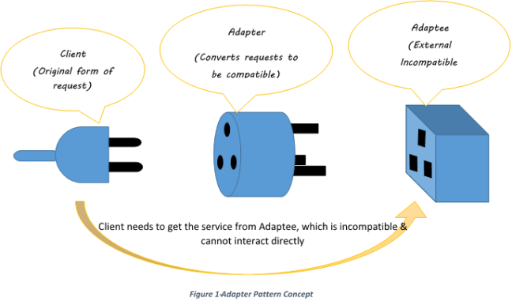
Adapter Pattern Component | Code in the Program | Role / Explanation
Target Interface | interface Temperature | Defines the expected method getTemperatureCelsius() that the client code wants to use.
Adaptee | class FahrenheitThermometer | Represents the existing system that provides temperature in Fahrenheit via getTemperatureFahrenheit().
Adapter | class CelsiusAdapter implements Temperature | Implements the target interface Temperature and internally uses FahrenheitThermometer to convert Fahrenheit to Celsius.
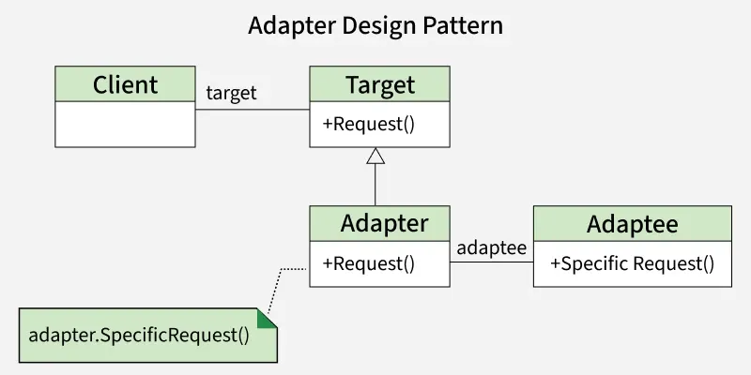

Program
// 1. Target Interface: What client expects
interface Temperature {
double getTemperatureCelsius();
}

// 2. Adaptee: Existing system providing Fahrenheit
class FahrenheitThermometer {
public double getTemperatureFahrenheit() {
return 98.6; // example value
}
}

// 3. Adapter: Converts Fahrenheit to Celsius
class CelsiusAdapter implements Temperature {
private FahrenheitThermometer thermometer;

public CelsiusAdapter(FahrenheitThermometer thermometer) {
this.thermometer = thermometer;
}

@Override
public double getTemperatureCelsius() {
double f = thermometer.getTemperatureFahrenheit();
return (f - 32) * 5 / 9; // conversion formula
}
}

// 4. Client code
public class AdapterDemo {
public static void main(String[] args) {
FahrenheitThermometer oldThermometer = new FahrenheitThermometer();
Temperature celsiusThermometer = new CelsiusAdapter(oldThermometer);

System.out.println("Temperature in Celsius: " + celsiusThermometer.getTemperatureCelsius());
}
}

Program Explanation

1. Target Interface (Temperature)
interface Temperature {
double getTemperatureCelsius();
}
- This is what the client expects.
- The client wants to get temperature in Celsius.
- Any class implementing this interface must provide the method:
getTemperatureCelsius()
- This is analogous to the “charge()” method in the charger example.

2. Adaptee (FahrenheitThermometer)
class FahrenheitThermometer {
public double getTemperatureFahrenheit() {
return 98.6; // example value
}
}

- This represents an existing system (like a thermometer that only provides Fahrenheit).
- Problem: The client wants Celsius, but the thermometer only gives Fahrenheit.
- It has a method incompatible with the client: getTemperatureFahrenheit().

3. Adapter (CelsiusAdapter)
class CelsiusAdapter implements Temperature {
private FahrenheitThermometer thermometer;

public CelsiusAdapter(FahrenheitThermometer thermometer) {
this.thermometer = thermometer;
}

@Override
public double getTemperatureCelsius() {
double f = thermometer.getTemperatureFahrenheit();
return (f - 32) * 5 / 9; // convert to Celsius
}
}

- Implements the Target Interface (Temperature).
- Contains a reference to the Adaptee (FahrenheitThermometer).
- When the client calls:
getTemperatureCelsius()
- The adapter calls the adaptee to get the Fahrenheit value:
thermometer.getTemperatureFahrenheit()
- Then it converts it to Celsius and returns it.

4. Client Code (AdapterDemo)
public class AdapterDemo {
public static void main(String[] args) {
FahrenheitThermometer oldThermometer = new FahrenheitThermometer();
Temperature celsiusThermometer = new CelsiusAdapter(oldThermometer);
System.out.println("Temperature in Celsius: " + celsiusThermometer.getTemperatureCelsius());
}
}

- The client wants to get temperature in Celsius.
- The client does not know that the thermometer provides Fahrenheit.
- Steps:
- Create the existing thermometer:
FahrenheitThermometer oldThermometer = new FahrenheitThermometer();
- Wrap it in an Adapter:
Temperature celsiusThermometer = new CelsiusAdapter(oldThermometer);

- Call the method expected by the client:
celsiusThermometer.getTemperatureCelsius();

- The adapter takes care of calling the old thermometer and converting the value.

5. Program Output
Temperature in Celsius: 37.0

- Fahrenheit 98.6 → Celsius 37.0
- The adapter does the conversion internally.
Lab Program 3 another example(Charging of Iphone6 using Iphone4 Charger)
// 1. Target Interface: What the client expects
interface Charger {
void charge(); // client wants to use this method
}

// 2. Adaptee: Existing system (iPhone 4s Charger)
class IPhone4sCharger {
public void connect() {
System.out.println("Charging using iPhone 4s charger...");
}
}

// 3. Adapter: Bridges the Adaptee to the Target Interface
class IPhone6sAdapter implements Charger {
private IPhone4sCharger oldCharger;

public IPhone6sAdapter(IPhone4sCharger oldCharger) {
this.oldCharger = oldCharger;
}

@Override
public void charge() {
// internally use the old charger
oldCharger.connect();
System.out.println("iPhone 6s is now charging through the adapter.");
}
}

// 4. Client Code
public class AdapterDemo {
public static void main(String[] args) {
// Old charger (Adaptee)
IPhone4sCharger oldCharger = new IPhone4sCharger();

// Adapter wraps the old charger
Charger adapter = new IPhone6sAdapter(oldCharger);

// Client uses the target interface
adapter.charge();
}
}

LAB PROGRAM 4
Title: Implementing Composite Design Pattern in Java
Problem Description: The above pattern can be implemented to represent the computer filesystem
which is composition of files and directories.
Method :
1. Component (FileSystemComponent): Defines a common interface for both files and directories,
including operations like display() and getSize().
2. Leaf (File): Represents individual files, implementing FileSystemComponent and providing
actual file behavior.
3. Composite (Directory): Represents a directory that can contain multiple FileSystemComponent
objects (both File and Directory). It implements methods to add/remove components and
delegates operations to its children.
4. Client (Main class): Uses the composite structure to treat files and directories uniformly
Theory Reference: Module 3

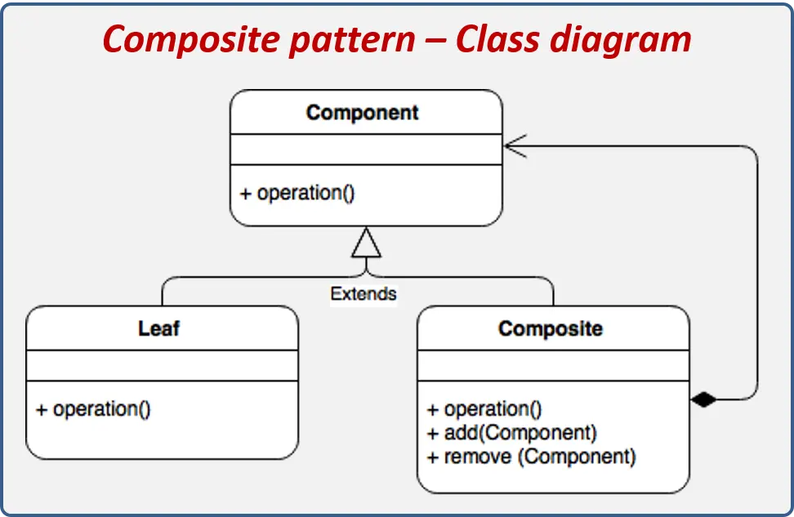
Program
import java.util.ArrayList;
import java.util.List;

// 1. Component
interface FileSystemComponent {
void display(); // display name
int getSize(); // size in KB
}

// 2. Leaf
class File implements FileSystemComponent {
private String name;
private int size;

public File(String name, int size) {
this.name = name;
this.size = size;
}

@Override
public void display() {
System.out.println("File: " + name + " (" + size + "KB)");
}

@Override
public int getSize() {
return size;
}
}

// 3. Composite
class Directory implements FileSystemComponent {
private String name;
private List<FileSystemComponent> children = new ArrayList<>();

public Directory(String name) {
this.name = name;
}

public void add(FileSystemComponent component) {
children.add(component);
}

public void remove(FileSystemComponent component) {
children.remove(component);
}

@Override
public void display() {
System.out.println("Directory: " + name);
for (FileSystemComponent component : children) {
component.display(); // delegate to children
}
}

@Override
public int getSize() {
int totalSize = 0;
for (FileSystemComponent component : children) {
totalSize += component.getSize(); // delegate to children
}
return totalSize;
}
}

// 4. Client
public class Main {
public static void main(String[] args) {
// Create files
File file1 = new File("file1.txt", 10);
File file2 = new File("file2.txt", 20);
File file3 = new File("file3.txt", 30);

// Create directories
Directory dir1 = new Directory("Documents");
Directory dir2 = new Directory("Images");

// Add files to directories
dir1.add(file1);
dir1.add(file2);
dir2.add(file3);

// Create root directory
Directory root = new Directory("Root");
root.add(dir1);
root.add(dir2);

// Display structure and total size
root.display();
System.out.println("Total size: " + root.getSize() + "KB");
}
}

Structure of the Program
Your program has four main parts:

Component (Interface)
interface FileSystemComponent {
void display();
int getSize();
}

Role:
- Declares common operations.
- Both File and Directory implement this.
- Ensures uniform treatment.

Methods:
- display() → prints name
- getSize() → returns size in KB

Leaf Class – File
class File implements FileSystemComponent

Role:
Represents individual objects (files).

What it does:
- Stores name
- Stores size
- Implements:
  - display() → prints file info
  - getSize() → returns file size

Example:
File file1 = new File("file1.txt", 10);
This is a leaf node (cannot contain children).

Composite Class – Directory
class Directory implements FileSystemComponent

Role:
Represents a collection of FileSystemComponent objects.
It can contain:
- Files
- Other directories

Key Feature:
private List<FileSystemComponent> children = new ArrayList<>();
This allows storing both File and Directory objects.

Important Methods:

➤ add()
Adds files or subdirectories.

➤ remove()
Removes a component.

➤ display()
- Prints directory name
- Calls display() on all children (delegation)

➤ getSize()
- Calls getSize() on each child
- Adds their sizes
- Returns total size
This is recursive behavior.

Client (Main Class)
public class Main

What happens in main():

Step 1: Create Files
File file1 = new File("file1.txt", 10);
File file2 = new File("file2.txt", 20);
File file3 = new File("file3.txt", 30);

Step 2: Create Directories
Directory dir1 = new Directory("Documents");
Directory dir2 = new Directory("Images");

Step 3: Add Files to Directories
dir1.add(file1);
dir1.add(file2);
dir2.add(file3);
Now:
Documents
├── file1 (10)
└── file2 (20)

Images
└── file3 (30)

Step 4: Create Root Directory
Directory root = new Directory("Root");
root.add(dir1);
root.add(dir2);
Final structure:
Root
├── Documents
│ ├── file1 (10)
│ └── file2 (20)
└── Images
└── file3 (30)

Step 5: Display Structure
root.display();

Output:
Directory: Root
Directory: Documents
File: file1.txt (10KB)
File: file2.txt (20KB)
Directory: Images
File: file3.txt (30KB)
This works because:
- Directory.display() calls display() on children
- Each object decides how to display itself
- This is polymorphism

Step 6: Calculate Total Size
System.out.println("Total size: " + root.getSize() + "KB");

Calculation:
file1 = 10
file2 = 20
file3 = 30

Total = 10 + 20 + 30 = 60KB

Output:
Total size: 60KB

LAB PROGRAM 5
Title: Implementing Model-View-Controller (MVC) Architecture in Java
Problem Description:
Student must implement the MVC pattern for student management system where student details (name,
roll number) are stored in a model, displayed through a view, and controlled via a controller. The system
should follow the Model-View-Controller (MVC) architecture to ensure separation of concerns, making
the code maintainable and scalable.
Method
1. Model (Student): Represents the data structure for storing student details. It contains getter and
setter methods for data manipulation.
2. View (StudentView): Responsible for displaying student information to the user. It takes data
from the model and presents it.
3. Controller (StudentController): Acts as a mediator between the model and the view. It handles
user input, updates the model, and refreshes the view accordingly.
4. Client (MVCPatternDemo): Initializes the model, view, and controller, demonstrating how they
Interact.
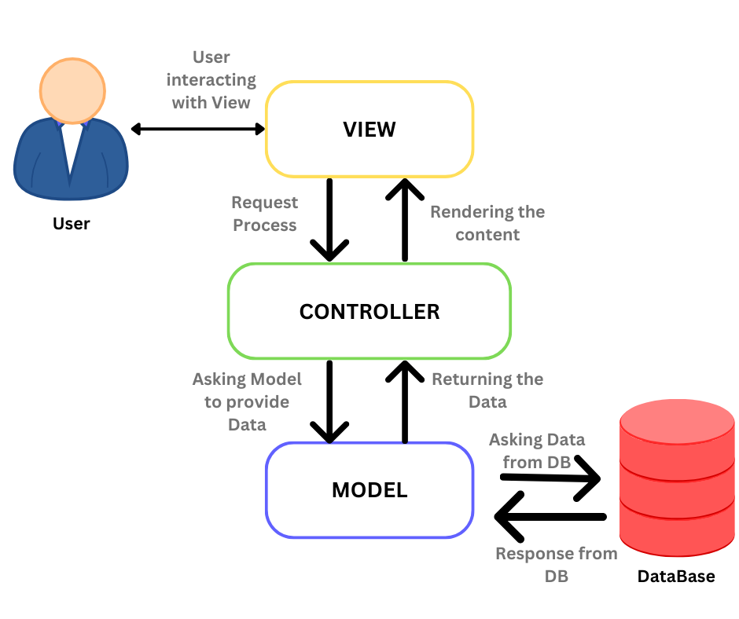
- The MVC is an architectural pattern that separates an application into Model, View, and Controller.
- Model: Responsible for maintaining data and its business related logic.
- View: Responsible for the representation of data to the user.
- Controller: Controls the interactions between the Model component and View component.

Program
// MVC Pattern - Single File Program

// Model
class Student {
private String name;
private String rollNo;

public String getName() {
return name;
}

public void setName(String name) {
this.name = name;
}

public String getRollNo() {
return rollNo;
}

public void setRollNo(String rollNo) {
this.rollNo = rollNo;
}
}

// View
class StudentView {
public void printStudentDetails(String studentName, String studentRollNo) {
System.out.println("Student Details:");
System.out.println("Name: " + studentName);
System.out.println("Roll No: " + studentRollNo);
}
}

// Controller
class StudentController {
private Student model;
private StudentView view;

public StudentController(Student model, StudentView view) {
this.model = model;
this.view = view;
}

public void setStudentName(String name) {
model.setName(name);
}

public void setStudentRollNo(String rollNo) {
model.setRollNo(rollNo);
}

public void updateView() {
view.printStudentDetails(model.getName(), model.getRollNo());
}
}

// Main Class (Client)
public class MVCPatternDemo {
public static void main(String[] args) {

// Create Model
Student model = new Student();
model.setName("John");
model.setRollNo("101");

// Create View
StudentView view = new StudentView();

// Create Controller
StudentController controller = new StudentController(model, view);

// Display initial details
controller.updateView();

// Update details
controller.setStudentName("David");
controller.setStudentRollNo("102");

System.out.println("\nAfter Updating Student Details:\n");

// Display updated details
controller.updateView();
}
}

Output
Student Details:
Name: John
Roll No: 101

After updating student details:

Student Details:
Name: David
Roll No: 102

Explanation of the Program

Model – Student Class
class Student {
private String name;
private String rollNo;
}

Purpose:
- Stores student data.
- Contains only data and getters/setters.
- Does NOT handle display or logic.

Methods:
- getName() / setName()
- getRollNo() / setRollNo()
The Model is responsible only for data management.

View – StudentView Class
class StudentView {
public void printStudentDetails(String studentName, String studentRollNo)

Purpose:
- Displays student information.
- Does NOT store data.
- Does NOT modify data.

Output Format:
Student Details:
Name: John
Roll No: 101
The View only shows data provided to it.

Controller – StudentController Class
class StudentController {
private Student model;
private StudentView view;
}

Purpose:
- Connects Model and View.
- Updates Model.
- Tells View when to refresh.

Key Methods:

➤ setStudentName()
Updates the model’s name.

➤ setStudentRollNo()
Updates the model’s roll number.

➤ updateView()
view.printStudentDetails(model.getName(), model.getRollNo());
This method:
- Gets data from Model
- Sends data to View
- View prints it
Controller controls everything.

Main Class – MVCPatternDemo
This is the client code.

Step-by-Step Execution

Step 1: Create Model
Student model = new Student();
model.setName("John");
model.setRollNo("101");
Model now contains:
Name = John
RollNo = 101

Step 2: Create View
StudentView view = new StudentView();

Step 3: Create Controller
StudentController controller = new StudentController(model, view);
Controller now links:
Model ↔ Controller ↔ View

Step 4: Display Initial Data
controller.updateView();
Flow:
Main → Controller → Model (get data)
↓
View (print)
Output:
Student Details:
Name: John
Roll No: 101

Step 5: Update Data via Controller
controller.setStudentName("David");
controller.setStudentRollNo("102");
Controller updates the Model.
Model now contains:
Name = David
RollNo = 102

Step 6: Display Updated Data
controller.updateView();
Output:
Student Details:
Name: David
Roll No: 102

LAB PROGRAM 6
Title: Implementing Client-Server Architecture in Java
Problem Description:
A simple client-server chat application needs to be developed where the server listens for incoming
client connections and clients can send messages to the server. The server should be able to receive
messages from multiple clients and respond accordingly. The system follows the Client-Server
Architecture, where the server handles requests and the client interacts with the server to exchange
messages.

Method:
1. Server (ChatServer): o Listens for incoming client connections on a specific port. o Handles multiple clients using multithreading. o Reads messages from clients and responds.
2. Client (ChatClient): o Connects to the server using a socket. o Sends messages to the server. o Receives responses from the server.
3. Multithreading for Concurrency: o The server spawns a new thread for each connected client to handle multiple clients
simultaneously.
Program

ChatServer.java
import java.io.*;
import java.net.*;

public class ChatServer {

public static void main(String[] args) {
try {
ServerSocket serverSocket = new ServerSocket(5000);
System.out.println("Server started. Waiting for clients...");

while (true) {
Socket socket = serverSocket.accept();
System.out.println("Client connected.");

// Create new thread for each client
new ClientHandler(socket).start();
}

} catch (IOException e) {
e.printStackTrace();
}
}
}

// Thread class to handle multiple clients
class ClientHandler extends Thread {
Socket socket;

public ClientHandler(Socket socket) {
this.socket = socket;
}

public void run() {
try {
BufferedReader input = new BufferedReader(
new InputStreamReader(socket.getInputStream()));

PrintWriter output = new PrintWriter(
socket.getOutputStream(), true);

String message;

while ((message = input.readLine()) != null) {
System.out.println("Client: " + message);

// Send response to client
output.println("Server received: " + message);
}

socket.close();

} catch (IOException e) {
e.printStackTrace();
}
}
}

ChatClient.java
import java.io.*;
import java.net.*;
import java.util.Scanner;

public class ChatClient {

public static void main(String[] args) {
try {
Socket socket = new Socket("localhost", 5000);

BufferedReader input = new BufferedReader(
new InputStreamReader(socket.getInputStream()));

PrintWriter output = new PrintWriter(
socket.getOutputStream(), true);

Scanner scanner = new Scanner(System.in);

System.out.println("Connected to server. Type messages:");

while (true) {
String message = scanner.nextLine();

output.println(message);

// Receive response from server
String response = input.readLine();
System.out.println(response);
}

} catch (IOException e) {
e.printStackTrace();
}
}
}

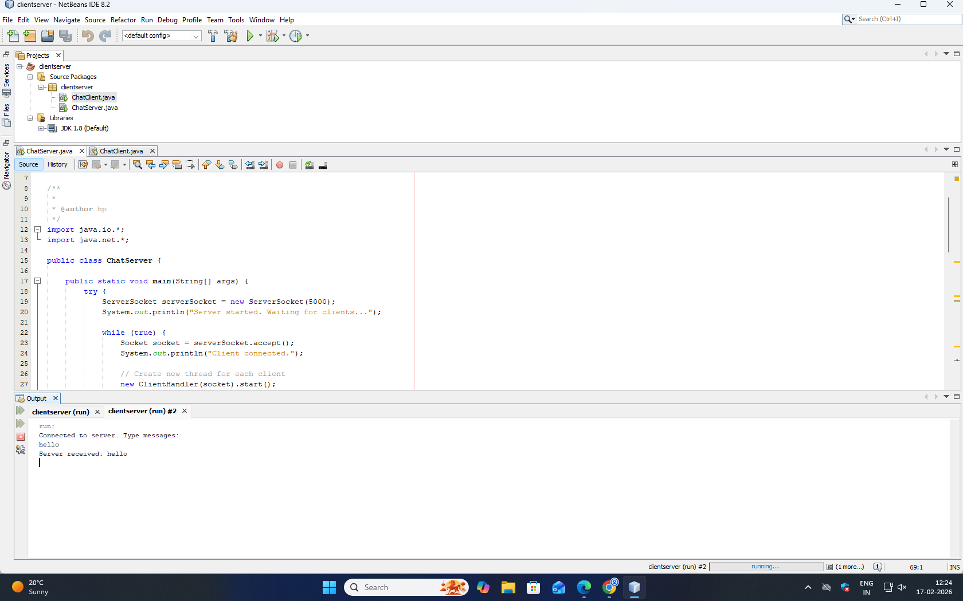

How It Works
- Server
  - Listens on port 5000
  - Accepts multiple clients
  - Creates a new thread for each client
  - Receives and responds to messages
- Client
  - Connects to server
  - Sends messages
  - Receives server response

LAB PROGRAM 7
Title: Implement the Observer pattern in java
Program Description: Students must demonstrate the above pattern to observe the events happening in
the stock market. Investors can subscribe to receive stock price updates for specific companies.
Method:
1. Subject: The subject maintains a list of observers and notifies them of state changes.
2. Observer: The observer interface defines the contract for concrete observer classes.
3. ConcreteSubject: A class that implements the subject interface and manages the observers.
4. ConcreteObserver: A class that implements the observer interface and receives notifications.
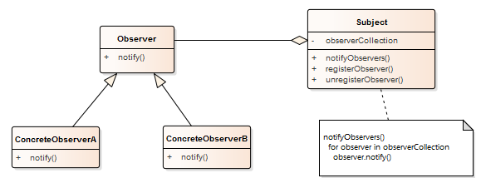
Diagram explanation

Diagram Overview:
This UML diagram represents the Observer pattern structure, which defines a one-to-many relationship between a Subject and its Observers. When the Subject changes state, it notifies all registered Observers.

Components in the Diagram:

1. Subject (Class)
- Attributes:
  - observerCollection — a collection (e.g., list) that stores all observers registered with this subject.
- Operations (Methods):
  - notifyObservers() — method that goes through all observers in observerCollection and calls their notify() method to update them about changes.
  - registerObserver() — method to add an observer to observerCollection.
  - unregisterObserver() — method to remove an observer from observerCollection.
- Role:
The Subject maintains state and manages its observers. When a significant event occurs (state changes), it notifies all observers.

2. Observer (Interface or Abstract Class)
- Operations:
  - notify() — method that observers must implement to receive updates from the subject.
- Role:
This is a contract for all concrete observers. Any class implementing this interface must define how to handle the notification (notify()).

3. ConcreteObserverA and ConcreteObserverB (Concrete Classes)
- Both inherit from Observer.
- Each implements the notify() method, which defines what action to take when the subject updates them.
- They represent different types of observers that react differently to subject notifications.

4. Relationships:
- Association:
  - Subject has a collection of Observer (aggregation indicated by the diamond near Subject).
  - This means Subject owns or manages many observers.
- Inheritance:
  - ConcreteObserverA and ConcreteObserverB inherit from Observer.
- Dependency:
  - notifyObservers() method depends on each observer's notify() method to update them.

How It Works (Step-by-Step):
- Observers register themselves with the Subject by calling registerObserver().
- When the Subject’s state changes, it calls notifyObservers().
- notifyObservers() loops through the observerCollection and calls notify() on each Observer.
- Each ConcreteObserver (ConcreteObserverA, ConcreteObserverB) implements notify() to perform its specific update action.
- Observers can unregister themselves anytime using unregisterObserver().

Summary
Component | Purpose
Subject | Manages observers and sends notifications
Observer (Interface) | Defines the update method notify()
ConcreteObservers | Actual observers that react to notifications

Real-Life Example Analogy
- Subject: Stock market company updating stock prices
- Observers: Investors who subscribe to updates
- When prices change, the company (Subject) notifies all investors (Observers).

Program
import java.util.*;

// 1. Observer interface
interface Investor {
void update(String company, double price);
}

// 2. Subject interface
interface StockMarket {
void addInvestor(Investor investor);
void removeInvestor(Investor investor);
void notifyInvestors();
}

// 3. Concrete Subject
class CompanyStock implements StockMarket {
private String companyName;
private double price;
private List<Investor> investors = new ArrayList<>();

public CompanyStock(String companyName, double price) {
this.companyName = companyName;
this.price = price;
}

public void setPrice(double price) {
this.price = price;
notifyInvestors(); // Notify investors on price change
}

@Override
public void addInvestor(Investor investor) {
investors.add(investor);
}

@Override
public void removeInvestor(Investor investor) {
investors.remove(investor);
}

@Override
public void notifyInvestors() {
for (Investor investor : investors) {
investor.update(companyName, price);
}
}
}

// 4. Concrete Observer
class InvestorImpl implements Investor {
private String name;

public InvestorImpl(String name) {
this.name = name;
}

@Override
public void update(String company, double price) {
System.out.println("Hello " + name + ", " + company + " stock price updated to: " + price);
}
}

// 5. Client
public class ObserverPatternDemo {
public static void main(String[] args) {
// Create companies
CompanyStock apple = new CompanyStock("Apple", 150.0);
CompanyStock google = new CompanyStock("Google", 2800.0);

// Create investors
Investor inv1 = new InvestorImpl("Alice");
Investor inv2 = new InvestorImpl("Bob");

// Subscribe investors to companies
apple.addInvestor(inv1);
apple.addInvestor(inv2);

google.addInvestor(inv2);

// Update stock prices
apple.setPrice(155.0);
google.setPrice(2850.0);

// Remove an investor
apple.removeInvestor(inv2);

// Update stock price again
apple.setPrice(160.0);
}
}
Program Explanation

Observer Pattern Concept Recap
The Observer pattern allows objects (observers) to subscribe to another object (subject) and automatically get notified of changes.
- Subject: Maintains state and observers.
- Observer: Gets notified when the subject’s state changes.
In this program:
- CompanyStock → Subject
- InvestorImpl → Observer

Observer Interface: Investor
interface Investor {
void update(String company, double price);
}
- Defines the contract for any investor.
- The update method will be called whenever the stock price changes.

Subject Interface: StockMarket
interface StockMarket {
void addInvestor(Investor investor);
void removeInvestor(Investor investor);
void notifyInvestors();
}
- Declares methods for adding/removing investors and notifying them.
- Any stock (company) that implements this interface can notify its subscribers.
Concrete Subject: CompanyStock
class CompanyStock implements StockMarket {
private String companyName;
private double price;
private List<Investor> investors = new ArrayList<>();
- Keeps company name and stock price.
- Maintains a list of investors (observers).
public void setPrice(double price) {
this.price = price;
notifyInvestors(); // Notify all investors
}
- Whenever the stock price changes, all subscribed investors are notified.
@Override
public void notifyInvestors() {
for (Investor investor : investors) {
investor.update(companyName, price);
}
}
- Iterates over the list of observers and calls their update() method.

Concrete Observer: InvestorImpl
class InvestorImpl implements Investor {
private String name;

public InvestorImpl(String name) {
this.name = name;
}

@Override
public void update(String company, double price) {
System.out.println("Hello " + name + ", " + company + " stock price updated to: " + price);
}
}
- Implements the Investor interface.
- Prints a notification message whenever update() is called.
- Each investor has a name to personalize notifications.

Client: ObserverPatternDemo
CompanyStock apple = new CompanyStock("Apple", 150.0);
Investor inv1 = new InvestorImpl("Alice");
apple.addInvestor(inv1);
apple.setPrice(155.0);
- Creates company stocks and investors.
- Investors subscribe to specific companies.
- When the company updates stock price, the subscribed investors are notified automatically.
- You can add or remove investors at any time using addInvestor() and removeInvestor().

Program Output Explained
Hello Alice, Apple stock price updated to: 155.0
Hello Bob, Apple stock price updated to: 155.0
Hello Bob, Google stock price updated to: 2850.0
Hello Alice, Apple stock price updated to: 160.0
- Alice and Bob received notifications based on the companies they subscribed to.
- After removing Bob from Apple, he no longer receives updates for Apple.

PRACTICE PROGRAM
Bridge Design Pattern
The Bridge Design Pattern is a structural design pattern that separates an abstraction from its implementation so that both can vary independently.
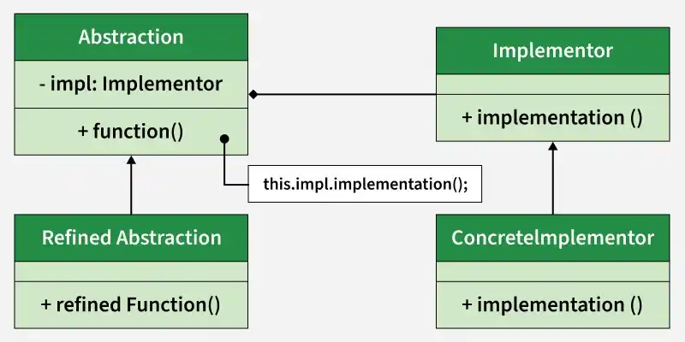

Components
- Abstraction: core of the bridge design pattern and defines the crux. Contains a reference to the implementer.
- Refined Abstraction: Extends the abstraction takes the finer detail one level below. Hides the finer elements from implementers.
- Implementer: It defines the interface for implementation classes. This interface does not need to correspond directly to the abstraction interface and can be very different. Abstraction imp provides an implementation in terms of operations provided by the Implementer interface.
- Concrete Implementation: Implements the above implementer by providing the concrete implementation.
Program
// Implementor
interface Color {
void applyColor();
}

// ConcreteImplementor 1
class Red implements Color {
public void applyColor() {
System.out.println("Coloring square Red");
}
}

// ConcreteImplementor 2
class Blue implements Color {
public void applyColor() {
System.out.println("Coloring square Blue");
}
}

// Abstraction
abstract class Shape {
protected Color color;

public Shape(Color color) {
this.color = color;
}

abstract void draw();
}

// RefinedAbstraction
class Square extends Shape {

public Square(Color color) {
super(color);
}

public void draw() {
System.out.println("Drawing Square");
color.applyColor(); // Bridge call
}
}

// Main class
public class BridgePatternDemo {
public static void main(String[] args) {

Shape redSquare = new Square(new Red());
redSquare.draw();

System.out.println();

Shape blueSquare = new Square(new Blue());
blueSquare.draw();
}
}
Explanation

What Problem Are We Solving?
Suppose we want:
- Different Shapes → Square, Circle
- Different Colors → Red, Blue
Without Bridge pattern, we would need many classes like:
- RedSquare
- BlueSquare
- RedCircle
- BlueCircle
This causes class explosion ❌
The Bridge Pattern solves this by separating:
- Shape hierarchy
- Color hierarchy
So both can change independently.

How the Program Works

Implementor → Color Interface
interface Color {
void applyColor();
}
- This defines the color behavior.
- It does not know about shapes.

Concrete Implementors → Red and Blue
class Red implements Color {
public void applyColor() {
System.out.println("Coloring square Red");
}
}
class Blue implements Color {
public void applyColor() {
System.out.println("Coloring square Blue");
}
}
- These classes implement the Color interface.
- They provide actual color logic.

Abstraction → Shape
abstract class Shape {
protected Color color;

public Shape(Color color) {
this.color = color;
}

abstract void draw();
}
Important points:
- Shape has a reference to Color
- This is the bridge connection
- Shape does not know which color exactly — it only knows it has a Color
This creates loose coupling.

Refined Abstraction → Square
class Square extends Shape {

public Square(Color color) {
super(color);
}

public void draw() {
System.out.println("Drawing Square");
color.applyColor();
}
}
What happens here:
- First it prints "Drawing Square"
- Then it calls color.applyColor()
- The actual color depends on which object we pass
This is runtime flexibility.

Main Method (How Objects Are Created)
Shape redSquare = new Square(new Red());
redSquare.draw();
Step-by-step:
- new Red() → creates Red color
- new Square(new Red()) → injects Red into Square
- draw() →
  - prints "Drawing Square"
  - calls Red’s applyColor()
Same for Blue:
Shape blueSquare = new Square(new Blue());

Key Bridge Pattern Concept
Shape ---------> Color
(has-a relationship)
- Shape and Color are separated
- They can vary independently
- They are connected using composition (object reference)

Advantages
✔ Avoids class explosion
✔ Follows Open/Closed Principle
✔ Easy to add new Shapes
✔ Easy to add new Colors
✔ Loose coupling

In One Line (Exam Answer)
Bridge Pattern separates abstraction (Shape) from implementation (Color) so that both can vary independently using composition instead of inheritance.

PRACTICE PROGRAM
Decorator Design pattern
The decorator pattern attaches additional responsibilities to an object dynamically. Decorators provide a flexible alternative to subclassing for extending functionality.
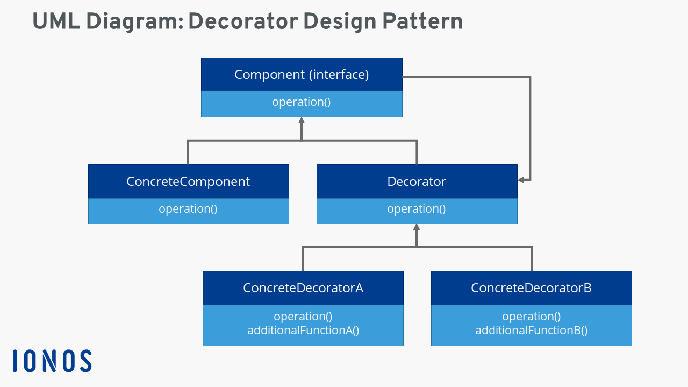
// Component interface
interface Component {
void operation();
}

// ConcreteComponent class
class ConcreteComponent implements Component {
public void operation() {
System.out.println("ConcreteComponent operation");
}
}

// Decorator class implementing Component and having a Component instance
abstract class Decorator implements Component {
protected Component component;

public Decorator(Component component) {
this.component = component;
}

public void operation() {
component.operation();
}
}

// ConcreteDecoratorA adds behavior
class ConcreteDecoratorA extends Decorator {
public ConcreteDecoratorA(Component component) {
super(component);
}

public void operation() {
super.operation();
additionalFunctionA();
}

public void additionalFunctionA() {
System.out.println("ConcreteDecoratorA additional function");
}
}

// ConcreteDecoratorB adds different behavior
class ConcreteDecoratorB extends Decorator {
public ConcreteDecoratorB(Component component) {
super(component);
}

public void operation() {
super.operation();
additionalFunctionB();
}

public void additionalFunctionB() {
System.out.println("ConcreteDecoratorB additional function");
}
}

// Test class with main method
public class DecoratorPatternDemo {
public static void main(String[] args) {
Component concrete = new ConcreteComponent();

Component decoratedA = new ConcreteDecoratorA(concrete);
Component decoratedB = new ConcreteDecoratorB(decoratedA);

decoratedB.operation();
}
}

Explanation:
- Component is the interface with the method operation().
- ConcreteComponent implements Component and defines the base operation.
- Decorator is an abstract class implementing Component and holding a reference to a Component object.
- ConcreteDecoratorA and ConcreteDecoratorB extend Decorator and add extra behavior.
- In main, a ConcreteComponent is wrapped by ConcreteDecoratorA, then further wrapped by ConcreteDecoratorB.
- When decoratedB.operation() is called, all layered operations run in order.
Output will be:
ConcreteComponent operation
ConcreteDecoratorA additional function
ConcreteDecoratorB additional function
Explanation of the program

1. Component Interface
interface Component {
void operation();
}
- This is the core interface that defines a common method (operation()) for all objects involved.
- Both the base object and decorators implement this interface, so they are interchangeable.

2. ConcreteComponent Class
class ConcreteComponent implements Component {
public void operation() {
System.out.println("ConcreteComponent operation");
}
}
- This is the original object that you want to add extra behaviors to.
- It implements operation() and provides the basic functionality.
- Example: Imagine a simple text printer printing "Hello".

3. Decorator Abstract Class
abstract class Decorator implements Component {
protected Component component;

public Decorator(Component component) {
this.component = component;
}

public void operation() {
component.operation();
}
}
- This is the base decorator class.
- It implements the same interface Component.
- It holds a reference to a Component object (the object it decorates).
- The constructor takes a Component and stores it.
- The operation() method by default delegates the call to the wrapped component.
- This class allows subclasses to add extra behavior before or after delegating the operation.

4. ConcreteDecoratorA Class
class ConcreteDecoratorA extends Decorator {
public ConcreteDecoratorA(Component component) {
super(component);
}

public void operation() {
super.operation();
additionalFunctionA();
}

public void additionalFunctionA() {
System.out.println("ConcreteDecoratorA additional function");
}
}
- This class extends the base decorator.
- It overrides the operation() method.
- First, it calls the base operation() using super.operation() to perform the original operation.
- Then, it adds new behavior by calling additionalFunctionA().
- This allows behavior to be added without modifying the original object.

5. ConcreteDecoratorB Class
class ConcreteDecoratorB extends Decorator {
public ConcreteDecoratorB(Component component) {
super(component);
}

public void operation() {
super.operation();
additionalFunctionB();
}

public void additionalFunctionB() {
System.out.println("ConcreteDecoratorB additional function");
}
}
- Same as ConcreteDecoratorA but adds a different extra behavior.
- This demonstrates how multiple decorators can add different functionalities independently.

6. Client Code (main method)
public class DecoratorPatternDemo {
public static void main(String[] args) {
Component concrete = new ConcreteComponent();

Component decoratedA = new ConcreteDecoratorA(concrete);
Component decoratedB = new ConcreteDecoratorB(decoratedA);

decoratedB.operation();
}
}
- First, you create a base component: ConcreteComponent.
- Then, you wrap it with ConcreteDecoratorA to add additional behavior A.
- Then, you further wrap the decorated object with ConcreteDecoratorB to add behavior B.
- When calling decoratedB.operation(), the call flows through all wrappers:
  - ConcreteDecoratorB.operation() calls
  - ConcreteDecoratorA.operation() which calls
  - ConcreteComponent.operation()
- Each decorator adds its own functionality on top.

Summary of call flow on decoratedB.operation():
- ConcreteDecoratorB.operation():
  - Calls super.operation() → ConcreteDecoratorA.operation()
  - Runs additionalFunctionB() (prints ConcreteDecoratorB additional function)
- ConcreteDecoratorA.operation():
  - Calls super.operation() → ConcreteComponent.operation()
  - Runs additionalFunctionA() (prints ConcreteDecoratorA additional function)
- ConcreteComponent.operation():
  - Prints ConcreteComponent operation

Output when running the program:
ConcreteComponent operation
ConcreteDecoratorA additional function
ConcreteDecoratorB additional function

PRACTICE PROGRAM
Facade Design Pattern
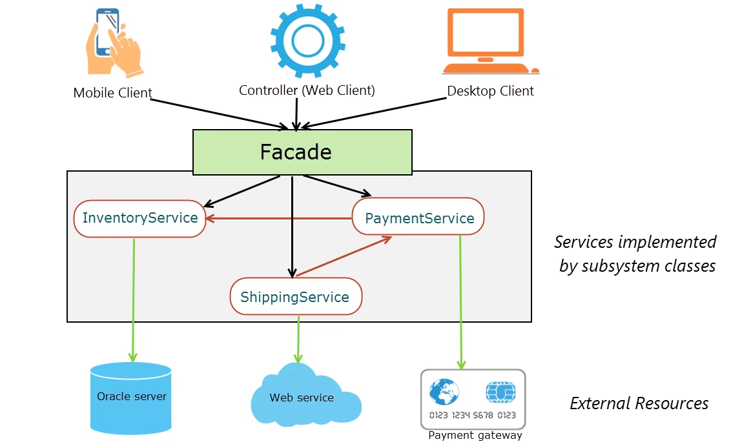
Components of Facade Pattern

Components Mapping (w.r.t GoF)
GoF Component | In This Example
Client | Main class
Facade | OrderFacade
Subsystem Classes | InventoryService,  PaymentService,  ShippingService

Program
// ---------------- Subsystem Classes ----------------

// Subsystem 1
class InventoryService {
public void checkStock(String product) {
System.out.println("Checking stock for " + product);
}
}

// Subsystem 2
class PaymentService {
public void makePayment(double amount) {
System.out.println("Processing payment of $" + amount);
}
}

// Subsystem 3
class ShippingService {
public void shipProduct(String product) {
System.out.println("Shipping product: " + product);
}
}

// ---------------- Facade ----------------

class OrderFacade {

private InventoryService inventory;
private PaymentService payment;
private ShippingService shipping;

public OrderFacade() {
inventory = new InventoryService();
payment = new PaymentService();
shipping = new ShippingService();
}

// Simplified method for client
public void placeOrder(String product, double amount) {
inventory.checkStock(product);
payment.makePayment(amount);
shipping.shipProduct(product);
System.out.println("Order placed successfully!");
}
}

// ---------------- Client ----------------

public class Main {
public static void main(String[] args) {

OrderFacade orderFacade = new OrderFacade();

// Client calls only ONE method
orderFacade.placeOrder("Laptop", 1000.0);
}
}

Program Explanation
We’ll break it into:
- Subsystem Classes
- Facade Class
- Client
- Flow of Execution
- Why this is actually Facade

1️ Subsystem Classes (The Real Workers)
These classes do the actual work.
They contain the business logic.

InventoryService
class InventoryService {
public void checkStock(String product) {
System.out.println("Checking stock for " + product);
}
}

What it does:
- Responsible for inventory operations
- Checks if product is available
In real systems, this might:
- Connect to database
- Verify quantity
- Reserve stock

PaymentService
class PaymentService {
public void makePayment(double amount) {
System.out.println("Processing payment of $" + amount);
}
}

What it does:
- Handles payment logic
- Talks to payment gateway
In real systems, this might:
- Connect to bank API
- Validate card
- Handle transaction response

ShippingService
class ShippingService {
public void shipProduct(String product) {
System.out.println("Shipping product: " + product);
}
}

What it does:
- Handles shipping process
- Arranges delivery

Important Observation
These subsystem classes:
Work independently
Don’t know about each other
Don’t know about Facade
Can be used directly
This is important in GoF definition.

2️ Facade Class – OrderFacade
This is the core of the pattern.
class OrderFacade {

private InventoryService inventory;
private PaymentService payment;
private ShippingService shipping;

Why private objects?
The Facade:
- Holds references to subsystem classes
- Controls access to them
- Coordinates them

Constructor
public OrderFacade() {
inventory = new InventoryService();
payment = new PaymentService();
shipping = new ShippingService();
}

What happens here?
When OrderFacade is created:
- It internally creates subsystem objects
- Client does NOT create them
This hides complexity from the client.

The Simplified Method
public void placeOrder(String product, double amount) {
inventory.checkStock(product);
payment.makePayment(amount);
shipping.shipProduct(product);
System.out.println("Order placed successfully!");
}

This is the key part.
Instead of the client calling:
- Check stock
- Process payment
- Ship product
The client just calls:
placeOrder()
The facade coordinates everything.

3️ Client – Main Class
public class Main {
public static void main(String[] args) {

OrderFacade orderFacade = new OrderFacade();
orderFacade.placeOrder("Laptop", 1000.0);
}
}

What client sees:
Only:
OrderFacade
The client does NOT know about:
- InventoryService
- PaymentService
- ShippingService
This reduces coupling.

4️ Step-by-Step Execution Flow
When program runs:

Step 1:
OrderFacade orderFacade = new OrderFacade();
→ Constructor creates subsystem objects.

Step 2:
orderFacade.placeOrder("Laptop", 1000.0);
Now inside placeOrder():
1️ inventory.checkStock("Laptop")
2️ payment.makePayment(1000.0)
3️ shipping.shipProduct("Laptop")
Everything is controlled by the facade.

5️ Why This Is Facade Pattern (GoF Definition)
GoF says:
"Provide a unified interface to a set of interfaces in a subsystem."
Let’s match that:
GoF Concept | In This Program
Subsystem | Inventory, Payment, Shipping
Facade | OrderFacade
Client | Main
Unified Interface | placeOrder()
Facade simplifies usage
Client is loosely coupled
Subsystems remain unchanged

PRACTICE PROGRAM
Chain of Responsibility
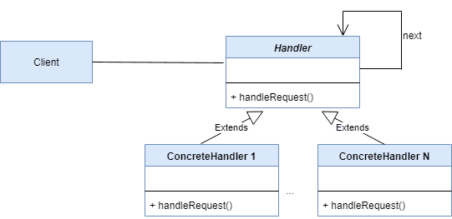
The Chain of Responsibility (CoR) is a behavioral design pattern where a request is passed along a chain of handlers. Each handler decides:
- ✔ Process the request
- ❌ Pass it to the next handler
This avoids coupling the sender of a request to its receiver.

Real-World Example
Think of a technical support system:
- Level 1 Support → handles basic issues
- Level 2 Support → handles intermediate issues
- Level 3 Support → handles critical issues
If Level 1 cannot handle it, the request moves to Level 2, then Level 3.

Components of Chain of Responsibility
Component | Role
Handler (Abstract) | Defines interface and reference to next handler
Concrete Handler | Handles request or forwards it
Client | Sends request to first handler
Program
// Simple Chain of Responsibility Example

// Step 1: Abstract Handler
abstract class Handler {
protected Handler nextHandler;

public void setNext(Handler nextHandler) {
this.nextHandler = nextHandler;
}

public abstract void handle(int number);
}

// Step 2: Concrete Handlers

class SmallNumberHandler extends Handler {
public void handle(int number) {
if (number < 10) {
System.out.println("Handled by SmallNumberHandler");
} else if (nextHandler != null) {
nextHandler.handle(number);
}
}
}

class MediumNumberHandler extends Handler {
public void handle(int number) {
if (number < 20) {
System.out.println("Handled by MediumNumberHandler");
} else if (nextHandler != null) {
nextHandler.handle(number);
}
}
}

class LargeNumberHandler extends Handler {
public void handle(int number) {
System.out.println("Handled by LargeNumberHandler");
}
}

// Step 3: Client
public class ChainDemo {
public static void main(String[] args) {

// Create handlers
Handler small = new SmallNumberHandler();
Handler medium = new MediumNumberHandler();
Handler large = new LargeNumberHandler();

// Create chain
small.setNext(medium);
medium.setNext(large);

// Send requests
small.handle(5);
small.handle(15);
small.handle(30);
}
}
Program Explanation

Step-by-Step Explanation

1.Abstract Handler Class
abstract class Handler {
protected Handler nextHandler;

public void setNext(Handler nextHandler) {
this.nextHandler = nextHandler;
}

public abstract void handle(int number);
}

Explanation:

protected Handler nextHandler;
- Stores reference to the next handler in the chain.
- This creates the chain structure.

setNext()
- Used to connect one handler to another.
Example:
small.setNext(medium);

abstract void handle(int number);
- Each subclass must define how to handle the request.
This is the base handler.

2.SmallNumberHandler
class SmallNumberHandler extends Handler {
public void handle(int number) {
if (number < 10) {
System.out.println("Handled by SmallNumberHandler");
} else if (nextHandler != null) {
nextHandler.handle(number);
}
}
}

How it works:
- If number < 10 → handled here.
- Otherwise → passes request to next handler.
Example:
- Input: 5 → handled here.
- Input: 15 → passed to MediumNumberHandler.

3.MediumNumberHandler
class MediumNumberHandler extends Handler {
public void handle(int number) {
if (number < 20) {
System.out.println("Handled by MediumNumberHandler");
} else if (nextHandler != null) {
nextHandler.handle(number);
}
}
}

How it works:
- Handles numbers less than 20.
- If not → passes to next handler.
Example:
- Input: 15 → handled here.
- Input: 30 → passed to LargeNumberHandler.

4.LargeNumberHandler
class LargeNumberHandler extends Handler {
public void handle(int number) {
System.out.println("Handled by LargeNumberHandler");
}
}

How it works:
- Handles all remaining numbers.
- Does NOT pass further (end of chain).

5.Client (Main Class)
public class ChainDemo {
public static void main(String[] args) {

Handler small = new SmallNumberHandler();
Handler medium = new MediumNumberHandler();
Handler large = new LargeNumberHandler();

small.setNext(medium);
medium.setNext(large);

small.handle(5);
small.handle(15);
small.handle(30);
}
}

Chain Creation
small.setNext(medium);
medium.setNext(large);
Chain looks like this:
Small → Medium → Large
All requests start from small.

Execution Flow

Case 1: small.handle(5)
- SmallNumberHandler checks: 5 < 10 ✔
- Handles it.
- Stops.
Output:
Handled by SmallNumberHandler

Case 2: small.handle(15)
- Small checks: 15 < 10 ❌
- Passes to Medium
- Medium checks: 15 < 20 ✔
- Handles it.
Output:
Handled by MediumNumberHandler

Case 3: small.handle(30)
- Small checks: ❌
- Medium checks: ❌
- Large handles it.
Output:
Handled by LargeNumberHandler

Final Output
Handled by SmallNumberHandler
Handled by MediumNumberHandler
Handled by LargeNumberHandler

Key Concepts Demonstrated
✔ Request is passed along chain
✔ Each handler decides responsibility
✔ Loose coupling between sender & receiver
✔ Easy to add new handler

Advantages of This Pattern
- Reduces dependency between classes
- Flexible request handling
- Easy to add new handlers
- Follows Open/Closed Principle

Disadvantages
- Request may go unhandled
- Harder to debug long chains
- Slight performance overhead

LAB PROGRAM 8
UML DIAGRAM
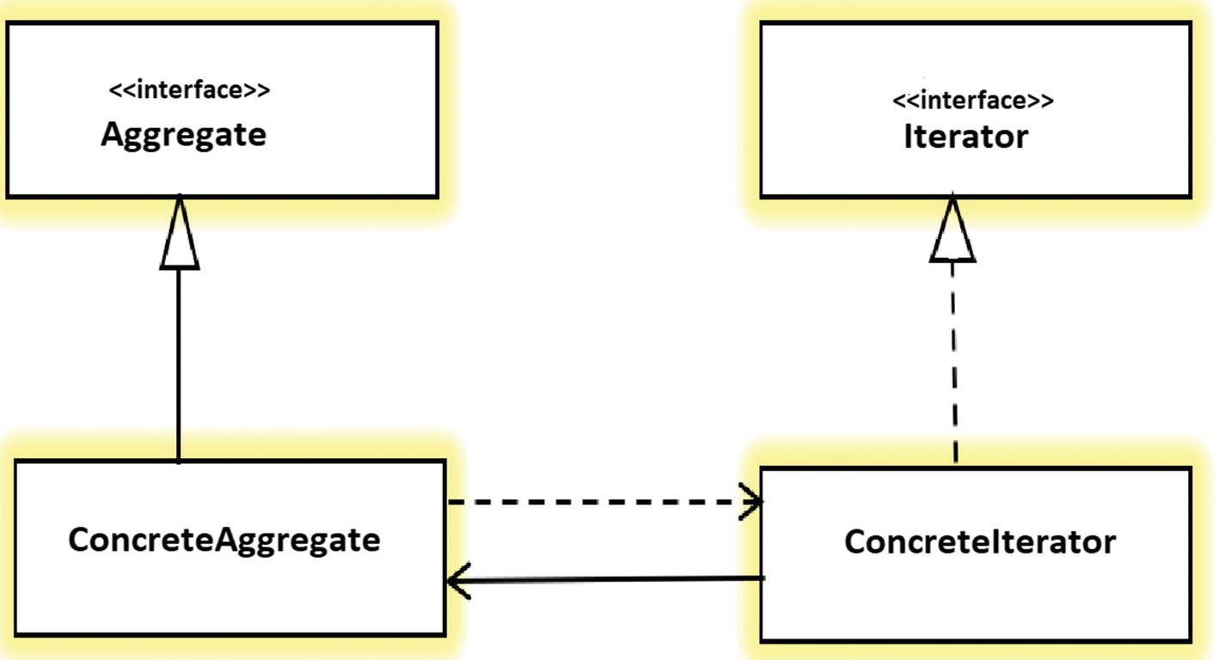
COMPONENTS
1. Iterator Interface
This interface defines the essential methods required for accessing and traversing the collection.
- Standard Methods: next() (returns the next element) and hasNext() (checks if more elements exist).
- Optional Methods: Some implementations include first(), currentItem(), or remove().
2. Concrete Iterator
This is the specific implementation of the Iterator interface for a particular collection.
- Responsibility: It maintains the current state of the traversal, such as the index or current position.
- Independence: Because it tracks its own progress, multiple iterators can traverse the same collection simultaneously and independently.
3. Aggregate (Collection) Interface
This interface (often called Iterable in many languages) defines the contract for the collection.
- Primary Method: It declares a factory method (e.g., createIterator()) that returns an instance of an iterator compatible with that collection.
4. Concrete Aggregate
This is the actual data structure class (like a List, Stack, or Tree) that stores the elements.
- Implementation: It implements the Aggregate interface and provides the logic to return a new instance of the corresponding Concrete Iterator.
PROGRAM
public class IteratorPatternSimple {

// 1. Iterator Interface
interface Iterator {
boolean hasNext();
Object next();
}

// 2. Aggregate Interface
interface Aggregate {
Iterator createIterator();
}

// 3. ConcreteAggregate
static class NameRepository implements Aggregate {
String[] names = {"A", "B", "C"};

public Iterator createIterator() {
return new NameIterator();
}

// 4. ConcreteIterator
private class NameIterator implements Iterator {
int index = 0;

public boolean hasNext() {
return index < names.length;
}

public Object next() {
return names[index++];
}
}
}

// 5. Client (main)
public static void main(String[] args) {
NameRepository repo = new NameRepository();
Iterator it = repo.createIterator();

while (it.hasNext()) {
System.out.println(it.next());
}
}
}

Output of the Program
A
B
C

Viva Questions

1. What is a design pattern?
A reusable solution to a common software design problem.

2. Why are design patterns important?
They improve maintainability, scalability, and communication among developers.

3. Who introduced design patterns?
Gang of Four (GoF).

4. How many GoF patterns exist?
23 patterns.

5. Categories of GoF patterns?
Creational, Structural, Behavioral.

6. Architecture vs Design Pattern?
Architecture defines system structure; pattern solves design problems.

7. Framework vs Pattern?
Framework is reusable code; pattern is reusable design concept.

8. What is loose coupling?
Low dependency between classes.

9. What is high cohesion?
A class focused on one responsibility.

10. What is abstraction?
Hiding implementation details.

11. What is encapsulation?
Binding data and methods together and restricting access.

12. What is polymorphism?
One interface, many implementations.

13. What is inheritance?
Deriving a class from another class.

14. What is composition?
Building classes using other class objects.

15. What is delegation?
Passing responsibility to another object.

24. What is UML?
Unified Modeling Language.

25. What is Class Diagram?
Shows class relationships.

26. What is Sequence Diagram?
Shows object interaction over time.

27. What is State Diagram?
Shows state transitions.

28. What is Code Smell?
Poor design indicator.

29. What is Refactoring?
Improving structure without changing behavior.

30. What is Anti-pattern?
Common bad solution to a problem.

31. What is GoF book name?
Design Patterns: Elements of Reusable Object-Oriented Software.

32. What is Object-Oriented Design?
Design based on objects and classes.

33. What is Dependency Injection?
Providing dependencies externally.

34. What is Tight Coupling?
High dependency between modules.

35. What is Reusability?
Ability to reuse code.

36. What is Scalability?
Ability to handle growth.

37. What is Maintainability?
Ease of modifying code.

38. What is Extensibility?
Ease of adding new features.

39. What is Interface?
Contract defining methods.

40. What is Abstract Class?
Class with abstract and concrete methods.

CREATIONAL PATTERNS (41–100)

Singleton (41–50)

41. What is Singleton?
Ensures only one instance exists.

42. Why use Singleton?
To control shared resources.

43. Lazy Initialization?
Instance created when needed.

44. Eager Initialization?
Instance created at class loading.

45. Thread-safe Singleton?
Use synchronized or double-check locking.

46. Real-world example?
Logger, Configuration manager.

47. Disadvantage?
Hard to test, global state issue.

48. Can reflection break Singleton?
Yes, unless prevented.

49. Can serialization break it?
Yes, unless readResolve() used.

50. When avoid Singleton?
When global state causes issues.

Factory Method (51–60)

51. What is Factory Method?
Creates objects without exposing instantiation logic.

52. Problem solved?
Removes tight coupling in object creation.

53. Real example?
Shape factory.

54. Advantage?
Follows OCP.

55. Disadvantage?
More classes required.

56. Creator class?
Declares factory method.

57. Product interface?
Common interface for created objects.

58. When use?
When object creation logic varies.

59. Factory vs Constructor?
Factory hides creation logic.

60. Factory vs Abstract Factory?
Factory creates one product; Abstract Factory creates families.

Abstract Factory (61–70)

61. What is Abstract Factory?
Creates families of related objects.

62. Family of objects?
Related objects designed to work together.

63. Real example?
GUI toolkit (Windows/Mac buttons).

64. Advantage?
Ensures product compatibility.

65. Disadvantage?
Hard to add new products.

66. Client role?
Uses factory interface only.

67. OCP support?
Yes.

68. Example scenario?
Cross-platform UI.

69. Difference from Factory?
Creates multiple related objects.

70. When avoid?
When products change frequently.

Builder (71–80)

71. What is Builder?
Separates object construction from representation.

72. Telescoping constructor problem?
Too many constructor parameters.

73. Real example?
StringBuilder.

74. Director role?
Controls building steps.

75. Advantage?
Readable object creation.

76. Disadvantage?
Extra code.

77. Immutable objects?
Yes.

78. When use?
Complex objects with many parameters.

79. Builder vs Factory?
Builder constructs step-by-step.

80. OCP support?
Yes.

Prototype (81–90)

81. What is Prototype?
Creates object by cloning.

82. Shallow copy?
Copies references.

83. Deep copy?
Copies objects fully.

84. Real example?
Object templates.

85. Advantage?
Reduces costly creation.

86. Disadvantage?
Complex cloning.

87. Java support?
Cloneable interface.

88. When use?
Costly object creation.

89. Problem solved?
Avoid repeated instantiation.

90. OCP support?
Yes.

Additional Creational Concepts (91–100)

91. What is Object Pool?
Reuses objects.

92. What is Dependency Injection?
Inject dependencies externally.

93. DI advantage?
Loose coupling.

94. DI types?
Constructor, Setter.

95. What is IoC?
Inversion of Control.

96. IoC vs DI?
DI is implementation of IoC.

97. Why use patterns?
To avoid reinventing solutions.

98. Can patterns combine?
Yes.

99. What is pattern intent?
Purpose of pattern.

100. What is pattern structure?
Classes and relationships.

STRUCTURAL DESIGN PATTERNS (101–150)

Adapter Pattern (101–110)

101. What is Adapter pattern?
Converts one interface into another expected by clients.

102. Problem solved by Adapter?
Interface incompatibility.

103. Real-life example?
Power plug adapter.

104. Types of Adapter?
Class Adapter and Object Adapter.

105. Which is more common?
Object Adapter (uses composition).

106. Adapter vs Decorator?
Adapter changes interface; Decorator adds behavior.

107. Adapter vs Facade?
Adapter converts interface; Facade simplifies interface.

108. Advantage of Adapter?
Improves reusability of existing code.

109. Disadvantage?
Adds extra layer of abstraction.

110. When use Adapter?
When integrating legacy systems.

Bridge Pattern (111–120)

111. What is Bridge pattern?
Separates abstraction from implementation.

112. Problem solved?
Class explosion due to multiple dimensions.

113. Real example?
Remote control and TV.

114. Key components?
Abstraction and Implementor.

115. Advantage?
Independent extensibility.

116. Disadvantage?
Increases complexity.

117. Bridge vs Adapter?
Bridge is planned; Adapter is retrofitted.

118. When use Bridge?
When abstraction and implementation vary independently.

119. Does Bridge use composition?
Yes.

120. OCP support?
Yes.

Composite Pattern (121–130)

121. What is Composite?
Treat individual and group objects uniformly.

122. Structure type?
Tree structure.

123. Components?
Component, Leaf, Composite.

124. Real example?
File system.

125. Advantage?
Simplifies client code.

126. Disadvantage?
Hard to restrict leaf operations.

127. Uses recursion?
Yes.

128. Composite vs Decorator?
Composite is tree; Decorator wraps object.

129. When use?
Hierarchical structures.

130. OCP support?
Yes.

Decorator Pattern (131–140)

131. What is Decorator?
Adds behavior dynamically.

132. Why use Decorator?
Alternative to subclassing.

133. Real example?
Coffee with toppings.

134. Advantage?
Flexible feature addition.

135. Disadvantage?
Many small classes.

136. Decorator vs Proxy?
Proxy controls access; Decorator adds functionality.

137. Uses composition?
Yes.

138. OCP support?
Yes.

139. Can stack decorators?
Yes.

140. When use?
When behavior must be added dynamically.

Facade Pattern (141–145)

141. What is Facade?
Provides simplified interface to complex subsystem.

142. Problem solved?
Subsystem complexity.

143. Real example?
Home theater system.

144. Advantage?
Reduces coupling.

145. Disadvantage?
May hide useful features.

Proxy Pattern (146–150)

146. What is Proxy?
Provides placeholder for another object.

147. Types of Proxy?
Virtual, Remote, Protection.

148. Real example?
ATM machine.

149. Advantage?
Controls access.

150. Proxy vs Decorator?
Proxy controls access; Decorator enhances behavior.

BEHAVIORAL DESIGN PATTERNS (151–200)

Observer Pattern (151–160)

151. What is Observer?
One-to-many dependency between objects.

152. Components?
Subject and Observer.

153. Real example?
YouTube subscribers.

154. Push model?
Subject sends full data.

155. Pull model?
Observer requests data.

156. Advantage?
Loose coupling.

157. Disadvantage?
Memory leaks if observers not removed.

158. Java support?
Observer interface (deprecated).

159. When use?
Event handling systems.

160. OCP support?
Yes.

Strategy Pattern (161–170)

161. What is Strategy?
Encapsulates interchangeable algorithms.

162. Problem solved?
Avoids large if-else blocks.

163. Real example?
Payment methods.

164. Strategy vs State?
Strategy changes behavior; State changes object state behavior.

165. Advantage?
Flexible algorithm selection.

166. Disadvantage?
More classes.

167. Uses composition?
Yes.

168. OCP support?
Yes.

169. When use?
When multiple algorithms exist.

170. Can change at runtime?
Yes.

State Pattern (171–180)

171. What is State?
Allows object to change behavior when state changes.

172. Real example?
Vending machine.

173. Context role?
Maintains state reference.

174. Advantage?
Removes complex conditionals.

175. Disadvantage?
Many state classes.

176. State vs Strategy?
State depends on internal state.

177. OCP support?
Yes.

178. When use?
When behavior depends on state.

179. Example?
Traffic light system.

180. Uses polymorphism?
Yes.

Command Pattern (181–190)

181. What is Command?
Encapsulates request as object.

182. Components?
Command, Receiver, Invoker.

183. Real example?
Remote control.

184. Advantage?
Supports undo/redo.

185. Disadvantage?
More classes.

186. When use?
GUI menu actions.

187. OCP support?
Yes.

188. Decouples?
Yes, sender and receiver.

189. Queue commands?
Yes.

190. Supports logging?
Yes.

Template Method (191–195)

191. What is Template Method?
Defines algorithm skeleton in base class.

192. Hook method?
Optional override method.

193. Real example?
Game framework.

194. Advantage?
Code reuse.

195. Disadvantage?
Less flexibility than Strategy.

Iterator Pattern (196–198)

196. What is Iterator?
Sequentially access elements without exposing structure.

197. Java example?
Iterator interface.

198. Advantage?
Simplifies traversal.

Mediator Pattern (199)

199. What is Mediator?
Centralizes communication between objects.

Memento Pattern (200)

200. What is Memento?
Captures and restores object state without exposing internals.

